HOMEWORK #25: INTRO TO DISCRETE PROBABILITY

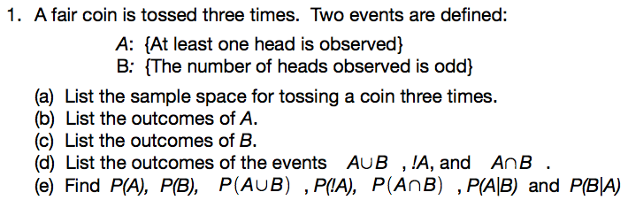

2.) Two dice are rolled (one is green and one is red.) Two events are defined.

A: {a 3 on the green die}
B: {a sum of 6 on the 2 dice}

Find P(A)

Find P(B)

Find P(!B)

Find P(A ∩ B)

Find P(A U B)

Find P(A|B)

- Suppose that 8% of all bicycle racers use steroids, that a bicyclist who uses steroids tests positive 96% of the time, and that a bicyclist who does not use steroids tests positive 9% of the time. What is the probability that a cyclist who tests positive for steroids actually uses steroids?

