RATIONAL FUNCTIONS
Graded Homework (30 Points) – Due Monday

For each rational function below. perform the following parts first without a graphing calculator. Only use a calculator at the END to check your work. You MAY use your notes, textbook, and calculator and even your classmates!

COMPLETE THE FOLLOWING 5 PARTS (FAITS) FOR EACH PROBLEM ON THE ANSWER SHEET. SHOW ALL WORK. USE A SEPARATE SHEET OF PAPER IF YOU PREFER!

- Factor completely.
- Asymptotes: Determine the equations of any asymptotes (horizontal, vertical, slant, and parabolic) if any.
- Intercepts: Determine the x and y intercepts
- Table: Determine the behavior of the function near the vertical asymptotes (if any).
- Sketch a graph of the function and sketch a dotted line of any asymptotes (or an open circle at any holes).

Problem 1:
$$r\left(x\right)= \frac{x^{2}-9}{x^{2}-4}$$

Problem 2:
$$g\left(x\right)= \frac{x^{2}+x-6}{x^{2}-25}$$

Problem 3:
$$t\left(x\right)= \frac{{(x}^{2}-4)(x+3)}{x^{2}+2x-3}$$

Problem 4:
$$u\left(x\right)= \frac{x^{3}-9x}{x+2}$$

NOTE: THERE IS A BACK PAGE WITH PROBLEMS 5, 6, and 7.
ANSWER SHEET:
Problem 1:
$$r\left(x\right)= \frac{x^{2}-9}{x^{2}-4}$$

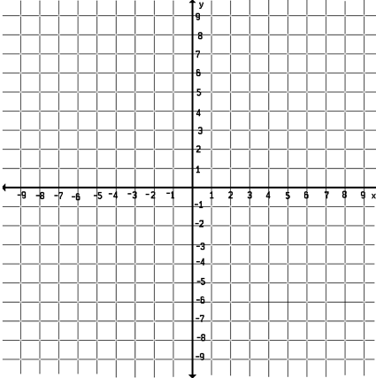
Problem 2:
$$g\left(x\right)= \frac{x^{2}+x-6}{x^{2}-25}$$

Problem 3:
$$t\left(x\right)= \frac{{(x}^{2}-4)(x+3)}{x^{2}+2x-3}$$

Problem 4:
$$u\left(x\right)= \frac{x^{3}-9x}{x+2}$$

PART 2: (section 3.5 and 3.6). Be sure to show ALL work.
5.) Complete the operation. Write your answer as a+bi.

6.) $i^{23} =$

7.) A polynomial is given below.
a.) Find ALL the zeros of the polynomial function
b.) Write the polynomial in its fully factored form.

